Togo - Project 1
Deanna Johnson
library(tidyverse)
── Attaching core tidyverse packages ──────────────────────── tidyverse 2.0.0 ──
✔ dplyr 1.1.4 ✔ readr 2.1.6
✔ forcats 1.0.1 ✔ stringr 1.6.0
✔ ggplot2 4.0.1 ✔ tibble 3.3.1
✔ lubridate 1.9.4 ✔ tidyr 1.3.2
✔ purrr 1.2.1
── Conflicts ────────────────────────────────────────── tidyverse_conflicts() ──
✖ dplyr::filter() masks stats::filter()
✖ dplyr::lag() masks stats::lag()
ℹ Use the conflicted package (<http://conflicted.r-lib.org/>) to force all conflicts to become errors
library(gapminder)
togo_df <- gapminder %>%
filter(country == "Togo")
us_df <- gapminder %>%
filter(country == "United States")

Togo Background
Togo is a West African country known for its diverse culture, rich history, and beautiful landscapes right in between Ghana and Benin. However, Togo is currently one of the poorest countries in the world, GDP per capita in 2019 stood at US$1,733, and almost half of the population (4 million people) live below the benchmark poverty line of US$1.90 for low-income countries (Aikins, 2025) .The economy is driven by agriculture and mineral exports. According to the United States Department of State (1987), approximately 75% of the population of Togo is engaged in agriculture, subsistence and cash crops.
From a public health student lens, this country particularly interests me because of their unfortunately limited access to healthcare to treat preventable diseases. In fact, the leading cause of death for this country is lower respiratory tract infections which include influenza and pneumonia. To put in perspective, there is less than one doctor for every 10,000 Togolese compared to 36 doctors for every 10,000 Americans (The Borgen Project, 2024). This project analyzes life expectancy trends in Togo and compares them with the United States to better understand how differences in healthcare access and health system structure shape population health outcomes.
mean_lifeExp <- mean(togo_df$lifeExp)
sd_lifeExp <- sd(togo_df$lifeExp)
n_years <- length(unique(togo_df$year))

Descriptive Statistics
Across 12 years of available data, the mean life expectancy in Togo was 51.5 years (SD =7.2).
ggplot(togo_df,
aes(
x = year,
y = lifeExp)
) +
geom_line(color = "red") +
geom_point() +
labs(
title = "Life Expectancy in Togo Over Time",
x = "Year",
y = "Life Expectancy (years)"
)
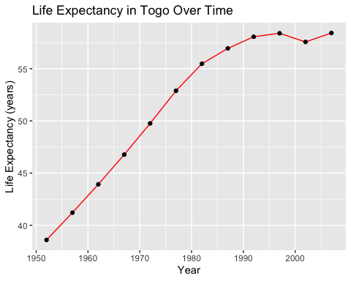
country_compare <- gapminder %>%
filter(country %in% c("Togo", "United States")) %>%
group_by(country) %>%
summarise(mean_lifeExp = mean(lifeExp))

Interpretation of Scatter Plot
The scatter plot highlights the life expectancy of Togo from 1952 to 2007. In 1952, life expectancy was below 40 years, but it steadily increased over time, reaching approximately 58 years by 2007. This upward trend may reflect improvements in maternal and child health services, expanded vaccination programs, and increased access to primary care. For example, the World Health Organization (2024) highlights progress in antenatal care coverage in Togo, which has contributed to improved maternal health outcomes. Additionally, Togo’s Expanded Program on Immunization has achieved high coverage rates for routine vaccines, including measles, polio, and DTP, while also introducing pneumococcal and rotavirus vaccines to reduce respiratory and diarrheal diseases (Fahad, 2024). More recently, the introduction of the malaria vaccine represents a large-scale national effort, targeting nearly 270,000 infants annually across Togo’s six health regions (Gavi, 2024). Because maternal and child health improvements are closely linked to reductions in infant and child mortality, these public health efforts likely contributed to the overall rise in life expectancy.
country_compare
# A tibble: 2 × 2
country mean_lifeExp
<fct> <dbl>
1 Togo 51.5
2 United States 73.5
ggplot(country_compare,
aes(
x = country,
y = mean_lifeExp,
fill = country)
) +
geom_col() +
scale_fill_manual(values = c("Togo" = "red",
"United States" = "blue"))+
labs(
title = "Average Life Expectancy (1952–2007)",
x = "Country",
y = "Mean Life Expectancy (Years)"
)
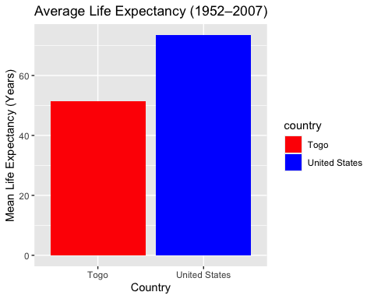

Interpretation of Bar Chart
The bar chart examines a comparison of Togo and the United States looking at the average life expectancy of both countries. The average life expectancy of a person in Togo is 51 years old while the average life expectancy in the United States is 73 years old. In fact, The United States spends more on health care than any similarly large and wealthy country(Peterson-KFF Health System Tracker, 2024). However, Although the United States spends more on healthcare than comparable high-income countries, it does not achieve proportionally higher life expectancy outcomes (Peterson-KFF Health System Tracker, 2024). Despite this high level of spending, the United States still has one of the lowest life expectancy rates among high income countries. Structural factors may contribute to this disparity. For example, research from The Commonwealth Fund (2022) indicates that U.S. adults are the least likely among high-income countries to have a longstanding relationship with a primary care provider. While the United States maintains a clear life expectancy advantage over Togo, this comparison shows that population health is influenced not only by national wealth or spending, but by how effectively health systems translate resources into accessible and equitable care.

Data Quality and Limitations
The gapminder dataset used in this analysis did not show substantial missing values for life expectancy in Togo across the selected years. However, the data are only available in five year intervals from 1952 to 2007. While the dataset provides valuable quantitative information about life expectancy, it does not explain the underlying causes of change. The data alone cannot determine whether improvements were directly caused by specific policies, economic growth, vaccination programs, or healthcare system reforms. Other important factors such as political stability, health infrastructure, education levels, and income inequality are not fully captured in this dataset as well.

Reflection
I truly enjoyed working on this project because not only did I learn how to code and generate graphs from real data, but I was also able to interpret the results and connect them to critical evidence that helps explain why the dataset looks the way it does. It made the numbers feel meaningful rather than abstract, and it strengthened my ability to think analytically about public health trends. What surprised me most was the comparison between Togo and the United States. While there is a clear difference in average life expectancy, I was intrigued by the fact that higher health care spending does not automatically translate into better health outcomes. This reinforced for me that life expectancy is shaped by multiple structural and social factors beyond medical care alone. If I were to continue this project, I would want to explore how occupational structure and working conditions influence health outcomes in Togo. This is because a large portion of the population is engaged in agriculture and manual labor, I am curious whether physically demanding work, environmental exposures, income instability, or limited labor protections contribute to differences in life expectancy.

References
Aikins, E. R. (2025, August 14). Togo. ISS Africa Futures. https://futures.issafrica.org/geographic/countries/togo/
Gavi, The Vaccine Alliance. (2024). Togo introduces malaria vaccine in health milestone. https://www.gavi.org/vaccineswork/togo-introduces-malaria-vaccine-health-milestone
Fahad, H. (2024). Togo’s vaccination progress. Gavi, The Vaccine Alliance. https://www.vaccinealliance.org/dqa-2003-madagascar-fr/
Peterson-KFF Health System Tracker. (2024). What drives differences in life expectancy between the U.S. and comparable countries? https://www.healthsystemtracker.org/chart-collection/what-drives-differences-in-life-expectancy-between-the-u-s-and-comparable-countries/#:~:text=The%20United%20States%20spends%20more,of%2082.5%20among%20peer%20countries.
Stein, R. (2026, January 29). U.S. life expectancy rises. NPR. https://www.npr.org/2026/01/29/nx-s1-5689902/us-life-expectancy-rises
The Borgen Project. (2024, November 29). Diseases impacting Togo. https://borgenproject.org/diseases-impacting-togo/
The Commonwealth Fund. (2022, March). Primary care in high-income countries: How the United States compares. https://www.commonwealthfund.org/publications/issue-briefs/2022/mar/primary-care-high-income-countries-how-united-states-compares
United States. Department of State. Bureau of Public Affairs (1987). Togo. Department of State publication. Background notes series, 1–6. https://pubmed.ncbi.nlm.nih.gov/12177930/
World Health Organization. (2024, August 26). Antenatal visits improve maternal health outcomes in Togo. WHO Regional Office for Africa.https://www.afro.who.int/countries/togo/news/antenatal-visits-improve-maternal-health-outcomes-togo?country=Togo&name=Togo

